

|  |  |  |
| --- | --- | --- |
| *Adderley Nursery School* | *Allens Croft Nursery School* | *Gracelands Nursery School* |
| *Highfield Nursery School* | *Jakeman Nursery School* | *Lillian de Lissa Nursery School* |
| *Newtown Nursery School* | *Shenley Fields Nursery School* | *St Thomas Centre Nursery School* |

**HOME VISITS & ABSENCE WELFARE CHECKS POLICY**

Full Governing Body Approved: 07 April 2025

Date for renewal: Spring 2027

Chair of Governors: Sean Delaney

Contents

Statement of Intent 2

**Home Visits** 2

Rationale for Carrying Out Initial Home Visits 2

Guidelines for Staff 3

Protocols for All Home Visits 5

Health and Safety 5

**Absence Home Visits or Absence Welfare Video Calls** 6

Absence Home Visits 6

Absence Welfare Video Calls 6

**Related policies** 6

**Appendix 1 - Risk assessment example** 8

**Appendix 2 – Parent / carer home visit information sheet** 9

This policy is in accordance with the 1989 United Nations Convention on the Rights of the Child (UNCRC).

***Article 2*** *(non-discrimination) The Convention applies to every child without discrimination, whatever their ethnicity, sex, religion, language, abilities or any other status, whatever they think or say, whatever their family background.*

***Article 3*** *(best interests of the child) The best interests of the child must be a top priority in all decisions and actions that affect children.*

***Article 5*** *(parental guidance and a child’s evolving capacities) Governments must respect the rights and responsibilities of parents and carers to provide guidance and direction to their child as they grow up, so that they fully enjoy their rights. This must be done in a way that recognises the child’s increasing capacity to make their own choices.*

***Article 15*** *(freedom of association) Every child has the right to meet with other children and to join groups and organisations, as long as this does not stop other people from enjoying their rights.*

***Article 28*** *(right to education) Every child has the right to an education. Primary education must be free and different forms of secondary education must be available to every child. Discipline in schools must respect children’s dignity and their rights. Richer countries must help poorer countries achieve this.*

### Statement of Intent

This policy is designed to protect the safety of all school staff carrying out home visits and detailing procedures for making home visits or absence welfare video calls. It is also designed to ensure the safety of children for whom are not in attendance at their nursery school place. This policy should be read in conjunction with each school’s Attendance Policy.

**Home Visits**

Purpose: starting a new nursery

### Rationale for Carrying Out Initial Home Visits

Nursery schools may visit a child in their home environment prior to them taking up their place. Childhood experiences lay the foundations for later life. Parenting has a critical impact on children’s emotional, behavioural and educational development, and their health and wellbeing. The school works in partnership with parents to ensure positive outcomes for children. One of the first steps in this partnership is, *where possible and appropriate*, to visit a child in their home environment, prior to them starting at one of our nursery schools. Where home visits are not achievable, an induction style welcome meeting with the parent carers and child will take place in nursery.

Visiting children and their family members in their home environment prior to them starting nursery has significant benefits. Staff are able to consider the child’s level of need in school and prepare for the child’s entry into the setting. The children also benefit from their key person visiting them at home, it often becomes a talking point upon the first few visits at nursery and beyond, providing a basis for the new relationship forming.

For teachers and support staff, a home visit provides the opportunity to:

* establish early, positive contact
* build up a warm caring relationship with the child and parent/carer before the child starts
* meet children in their own familiar setting
* meet other family members, people and pets who are important to the child
* encourage parents to share with us as much information as possible about their child to support with settling in and future learning needs being met
* get a ‘wider view’ of the family such as customs, beliefs, child rearing practices and systems upon which to build or support
* work in partnership with parent/carers and their children to support early intervention on specific issues relating to their child’s development. These usually take the form of behaviour, speech and language, personal, social and physical development
* share information about the school and break barriers down, especially if parent/carers have deep routed anxieties about their child starting nursery school
* get a picture of the child’s interests to begin our planning with a child-initiated approach to learning
* understand the problems that children might encounter at school, and also to appreciate the wealth of learning that goes on in the home

### Guidelines for Staff

**Structure of EYFS home visits**

Staff make home visits in pairs. As well as the obvious safety implications, this allows one staff member to talk to the child’s parents/carers and the other to focus solely on the child. This means that the parent/carer has focused time with a member of our staff team. Thirty minutes is the standard period of time devoted to each home visit. Visits typically take place either during the term before children are due to start attending nursery or at the beginning of the term they start. In some terms, staff capacity may mean that home visits are not possible and building the new relationship will be done in other ways. Parents are always contacted in advance to confirm the appointment of a scheduled home visit.

**Equipment needed**

All visits need careful structuring and prepared resources. Visiting staff members will take an information pack with them when visiting a child and their parents / carers in their home. This would usually contain photographs of staff, details of the nursery day, along with the standard forms that would need to be filled in by the parents/ carers. A child may then engage in activity with a staff member whilst the other staff member interacts with the parent/carer.

Staff should also take a mobile phone for safety reasons, a map to locate addresses, and a few toys and books for the child to play with.

**Before the visit**

* Make appointments in advance and offer alternative dates/times
* Ensure that parents know roughly when you will arrive, how long you will stay, what will happen, what kinds of questions you will be asking and what information you will bring (Appendix 2 – Parents’ Information Sheet)
* Ask them to think about the information they need from you in advance of the meeting
* Accept the right of a family not to accept a home visit
* Confirm parents/carers name and title and keep on record. Do not presume that there are two parents with the same surname as the child
* Do not assume that all parents/carers are literate
* Make sure you consider diversity of social, cultural, racial, religious and sexual orientation
* Familiarise yourself with the location of the home and the route you will take before you leave
* Leave details of your visiting schedule with another member of staff in nursery
* Ensure you have a charged mobile phone

**During the visit**

* Wear the school lanyard with ID badge on to informs the parent of who you are
* Show respect for parents/carers as equal partners
* Be a good listener
* Be aware of pets and other adults who may be in the home
* Sit near a door or exit and if you feel uneasy or worried at any time, make an excuse and leave
* Staff should avoid commenting on a child’s home or provision so that parents do not feel that any judgement is being made on their home or lifestyle
* Staff should demonstrate an awareness and respect for differing cultures
* They should comply with appropriate customs such as removing shoes, wearing modest clothing etc.
* Staff should remain aware of time constraints on both themselves and parents

**After the visit**

* Share relevant information with a Senior Leader where necessary
* Staff to complete My Concern if any safeguarding concerns identified
* If any incident has occurred or any concerns arise with regards to safeguarding, staff should record concerns and contact Head teacher/ Deputy Head teacher immediately
* Team to meet to reflect current procedures and disseminate any relevant information to all staff

### Protocols for All Home Visits

**Risk Assessment:**

* Where possible, check records to see what information is available
* Talk to other professionals who may already have had contact or involvement with the family
* Obtain information about the location of the home visit. For example, does the area have a reputation for being unsafe, isolated or poorly lit?
* Discuss strategies to adopt when working with a potentially challenging parent / carer / family member with a line manager
* Where risks are identified, arrange an alternative meeting environment

### Health and Safety

* A home visits risk assessment should be read and understood by staff members undertaking home visits. This will identify any potential risks and appropriate measures to be taken
* Inform a nominated member of staff when you are leaving for a home visit
* Leave the details of the home visit schedule with a senior member of staff. Include a list of visit addresses and times including family name, child’s name, address and telephone number. If a safeguarding visit is being carried out, ensure a senior member of staff remaining in school knows the reason for the visit
* You must inform the nominated person if there is a cancellation or alteration to the time
* Carry with you and show the parent some form of identification
* Demonstrate normal courtesy – wait to be invited into the home
* If a child answers the door, ask if an adult is present in the house before entering. Do not enter if an adult is not present
* If the parent / carer appears at all uncomfortable about the visit continuing, staff should offer to leave, offer to continue the contact with a telephone call and give the parent / carer the telephone number of the school
* Use common sense, trust your instincts and if a situation feels dangerous or threatening – leave
* When entering homes, call the designated person back at school when entering the house and again immediately after leaving the house
* The designated person will call to check in if the visit has taken longer than 30 minutes. If the phone is not answered on 2 occasions, an alert will be made and help will be sought

**Absence Home Visits or Absence Welfare Video Calls**

### Absence Home Visits

Where a home visit is required in order to comply with the school’s Attendance Policy, the procedure is:

* Where possible, make phone contact to agree a mutually convenient time.
* Where contact cannot be made, the visit may be unannounced.
* Door step visits only, staff will not go into the family home.
* A DSL must attend the visit alongside another member of staff.
* Knock and step back from the front door.
* Always wear your school identity card.
* Inform the parent why you are visiting (no contact, school safeguarding procedure).
* Ensure you have physically seen the child. If the child is not available to physically be seen, a follow up home visit must be arranged.
* Document your visit onto the school’s My Concern database at the next possible opportunity.
* Share any concerns with any other professionals involved. If children are on a Child Protection or CIN plan, inform the social worker.

### Absence Welfare Video Calls

Where a home visit - in order to comply with the school’s Attendance Policy - is not possible, or where a video call is more appropriate, a school mobile phone can be used for a DSL to make a video call to the parent. The procedure is:

* Inform the parent by phone to get consent to make the video call and agree a mutually convenient time.
* When making the video call, inform the parent why you are doing so.
* During the call, ensure you have physically seen the child on screen. If the child is not available to physically be seen, a follow up home visit must be arranged.
* Document your call onto the school’s My Concern database at the next possible opportunity.
* Share any concerns with any other professionals involved. If children are on a Child Protection or CIN plan, inform the social worker.

Where contact cannot be made through a home visit or video call for the purpose of an absence welfare check, the attendance policy will be used and a police safe and well check may be requested.

**Related policies**

This list of related policies is not exhaustive:

* Guidance for safer working practice for those working with children and young people in education settings
* Health and Safety
* Data Privacy Notice
* Safeguarding and Child Protection
* Lone Working
* Code of Conduct School Staff

(Absence Welfare Video Calls)

* Attendance
* Uncollected and Missing Children

**Appendix 1 - Risk assessment example**

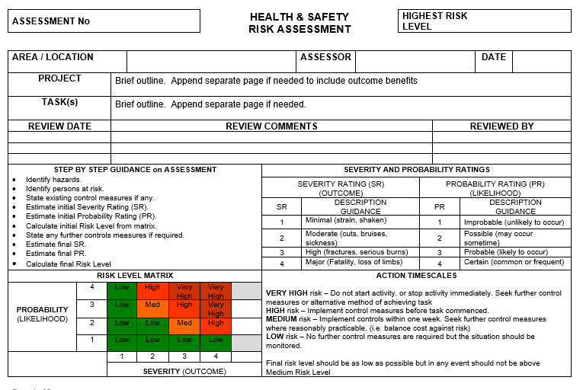

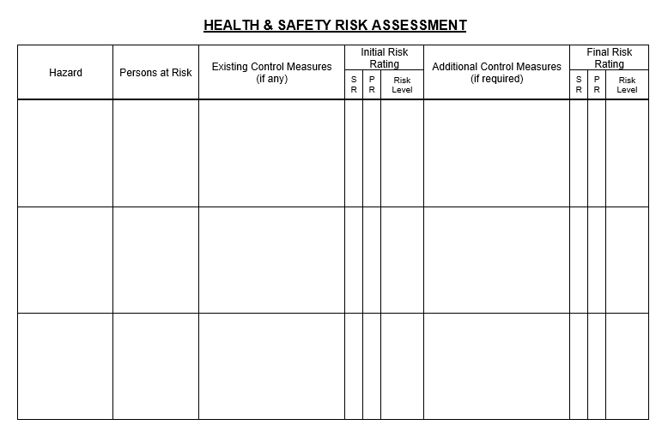

**Appendix 2 – Parent / carer home visit information sheet**

**What is a home visit?**

As the name suggests, a home visit is an informal visit to your home by school staff.  
It is usually carried out when your child has been offered a place at the setting but before they actually start.

**Why do home visits?**

Home visits are a really good way for staff to begin to get to know both you and your child and vice versa.  
It is a great opportunity to spend some time in a relaxed atmosphere, exchanging information and planning your child’s start at the setting. You will also have the chance to ask questions and express any concerns you may have.

It is not an inspection of you or your home!  
You are under no obligation to accept a home visit and a meeting can be arranged at the setting if you prefer.  
All information is considered confidential and will not be shared without your permission.

**Practicalities**

**Who will do the home visit?**

2 members of school staff will visit your home.

**How long will it take?**

The length of the visit can vary; it is usually around 30 minutes.

**What will happen at the home visit?**

We know that children like to be busy and active!  
One member of staff will usually get to know your child by playing with them and showing them books or photos of the setting.

Your child may also like to share some of their favourite toys or activities with the practitioner.  
The other member of staff will complete some basic information forms with you, give you a welcome pack and go through some details about your child starting nursery school.  
You will also have the opportunity to ask any questions or share any concerns you may have.

**How should I prepare for a home visit?**

* Have some basic information to hand such as your doctor’s name and address, your emergency contact details etc. in order to speed up the form filling process.
* Try to remove any distractions, for example family pets. It is also helpful if the television has been turned off.
* Have some of your child’s favourite toys or play things available as these can help the practitioner to engage with your child.
* Prepare a list of questions you may want to ask.
* If you have any questions, worries or concerns about your home visit or would like any further information, please contact us at the setting.